=====================================

Assignment 1 Submission

Name: **Sumit Kumar Yadav**

Roll number: **18CS30042**

Link of the pcap file: <https://drive.google.com/file/d/1cc7JHK3ap6U6qpKNo_gD7BdvRsQ2iakL/view?usp=sharing>

=====================================

1. **Layer of Protocol Stack :-**

a. Application layer :- DNS, HTTP

b. Transport Layer :- TCP, UDP, TLSv1.2, TLSv1.3

c. Network Layer :- ARP

2**. Total amount of Data being Received :-**

a. <http://iitkgp.ac.in> :- 1705714 bytes (35.2%)

b. <https://www.cornell.edu> :- 2083499 bytes (42.9%)

3. **Total DNS packets observed = 829**

1. Some of the observed DNS packets are :-

All DNS found in this excel sheet (<https://drive.google.com/file/d/1RrXebl76wxClbFz9G2gQ2wrJ4U5OlRXN/view?usp=sharing> )

|  |  |  |
| --- | --- | --- |
| **Serial No.** | **Domain Name** | **IP** |
| 1. | iitkgp.ac.in | 203.110.245.244 |
| 2. | www.cornell.edu | 20.42.25.107 |
| 3. | iitkgpmail.iitkgp.ac.in | 203.110.245.235 |
| 4. | googlemail.l.google.com | 172.217.166.5 |
| 5. | www.international.iitkgp.ac.in | 203.110.245.243 |
| 6. | www.library.iitkgp.ac.in | 203.110.245.243 |
| 7. | www.gian.iitkgp.ac.in | 203.110.245.243 |
| 8. | gate.iitkgp.ac.in | 203.110.245.11 |
| 9. | alumni.iitkgp.ac.in | 203.110.242.132 |
| 10. | som.iitkgp.ac.in | 203.110.240.154 |
| 11. | www.google.com | 142.250.183.4 |
| 12. | kronos.metakgp.org | 104.24.122.52 |
| 13. | github.com | 13.234.210.38 |

1. The IP of the DNS server :- 192.168.43.1

4. **After Accessing the site** [**http://iitkgp.ac.in**](http://iitkgp.ac.in)

a. Total HTTP GET requests observed = 20

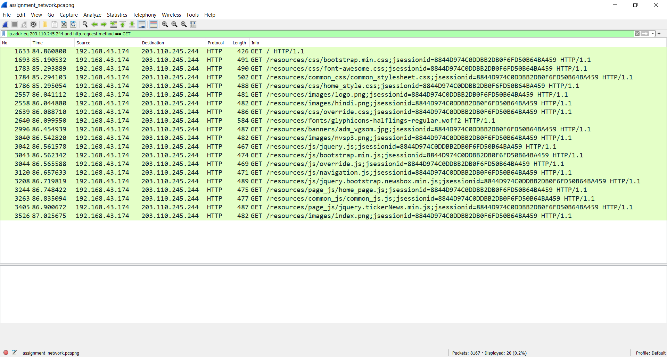attached image contains the details of these HTTP GET request:-

b. Details of HTTP Response message of the corresponding HTTP GET Requests are shown in the below table :-

|  |  |  |  |  |
| --- | --- | --- | --- | --- |
| **Sr. No.** | **Query frame number** | **Response frame number** | **Total number of TCP Segments being received** | **Total amount of data being received (in Bytes)** |
| 1. | 1633 | 3037 | 683 | 934075 |
| 2. | 1693 | 2547 | 104 | 141167 |
| 3. | 1783 | 2249 | 27 | 35495 |
| 4. | 1784 | 2124 | 16 | 19706 |
| 5. | 1786 | 1952 | 8 | 8718 |
| 6. | 2557 | 2752 | 14 | 17250 |
| 7. | 2558 | 2732 | 3 | 2196 |
| 8. | 2639 | 2838 | 6 | 6815 |
| 9. | 2640 | 1952 | 8 | 8718 |
| 10. | 2996 | 3524 | 176 | 239321 |
| 11. | 3040 | 3118 | 8 | 9123 |
| 12. | 3042 | 3439 | 72 | 95981 |
| 13. | 3043 | 3412 | 28 | 37058 |
| 14. | 3044 | 3197 | 7 | 8012 |
| 15. | 3120 | 3254 | 3 | 2176 |
| 16. | 3208 | 3404 | 5 | 5456 |
| 17. | 3244 | 3426 | 5 | 4821 |
| 18. | 3263 | 3444 | 4 | 3024 |
| 19. | 3405 | 3513 | 4 | 4183 |
| 20. | 3526 | 3541 | 6 | 5750 |